**HOW TO USE THE TYPING TESTER DESKTOP APPLICATION SYSTEM**

**Step 1: Download and Setup:** The very first thing to do is to download the complete file from my GitHub page and then set up this file on your own computer, ensuring that all the relevant “imports or modules and data libraries”, as intentionally used at the topmost section of the main file “Final_TestTypingApp.py” are downloaded and installed on your own computer.

**Step 2: Testing Application:** You can place the complete downloaded application file from my GitHub on any location of choice on your computer and open or run the main “Final_TestTypingApp.py” file with any Python IDEs or command editors of your choice. I used “VSCode” to develop the application. This same tool can be used if you prefer it to others.

Upon running the main application on your computer, there come up two user interfaces as shown below. The login or registration form and the main user interface form where the typing test exercises take place. Your inputted time in minutes is automatically converted to seconds upon the click of the “Start Test” golden button on the user interface after the delay count is over. It is also possible to create a new user “Username and Password”. The file “**users.csv**” in the complete downloaded file, contains the usernames and passwords of already existing users. These users’ credentials can be used to access the application or you can register new users of your choice.

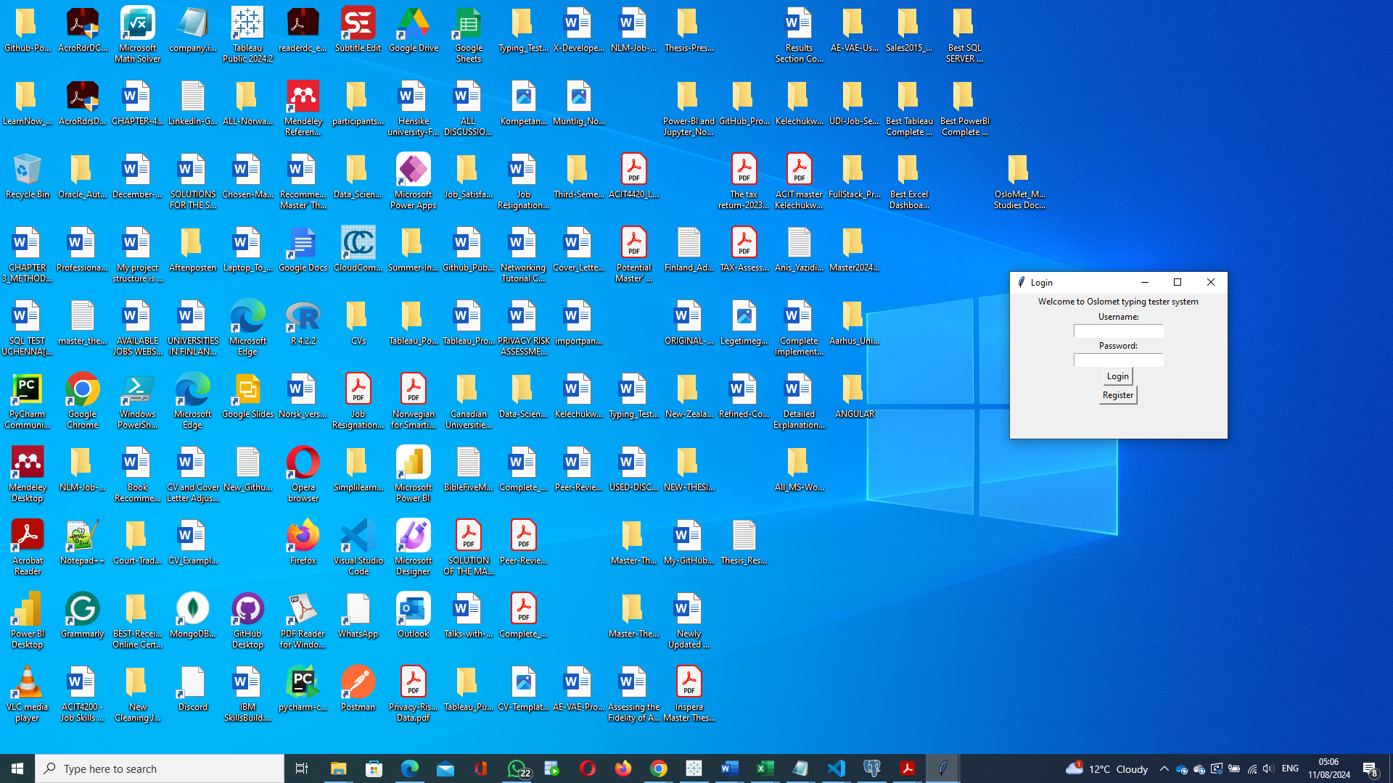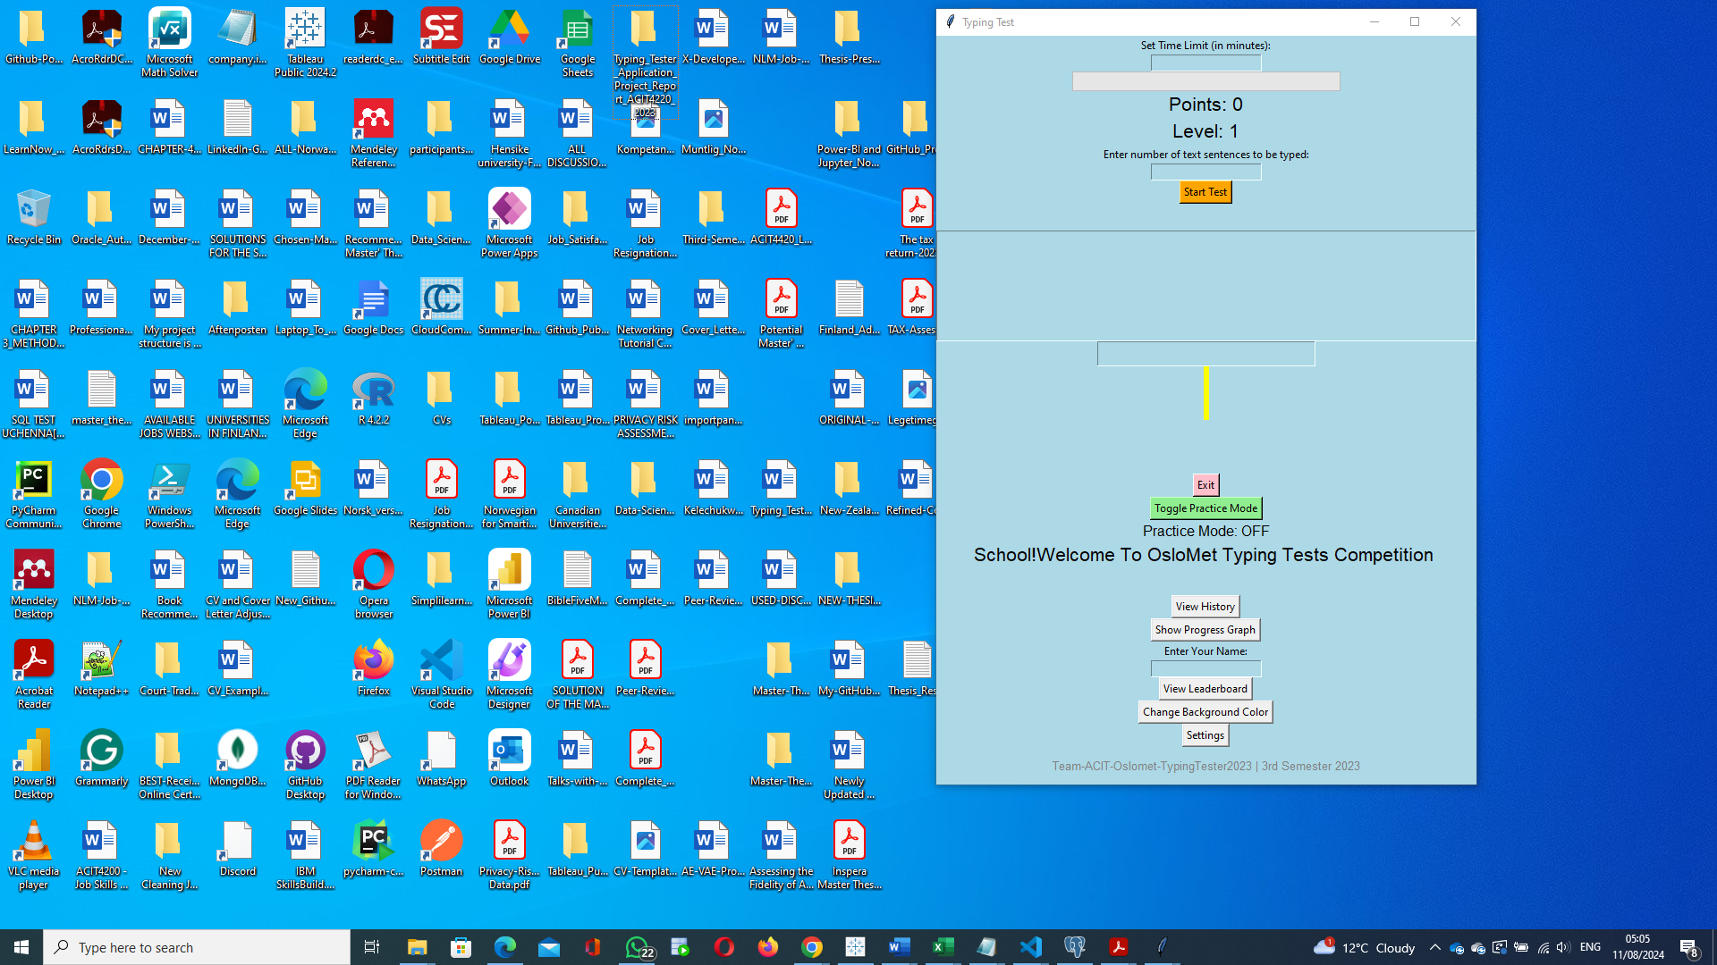

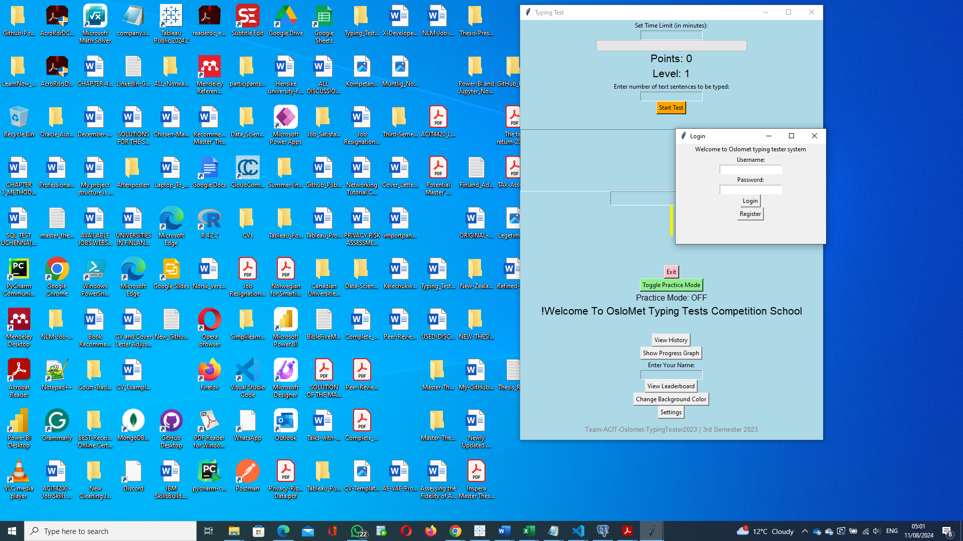

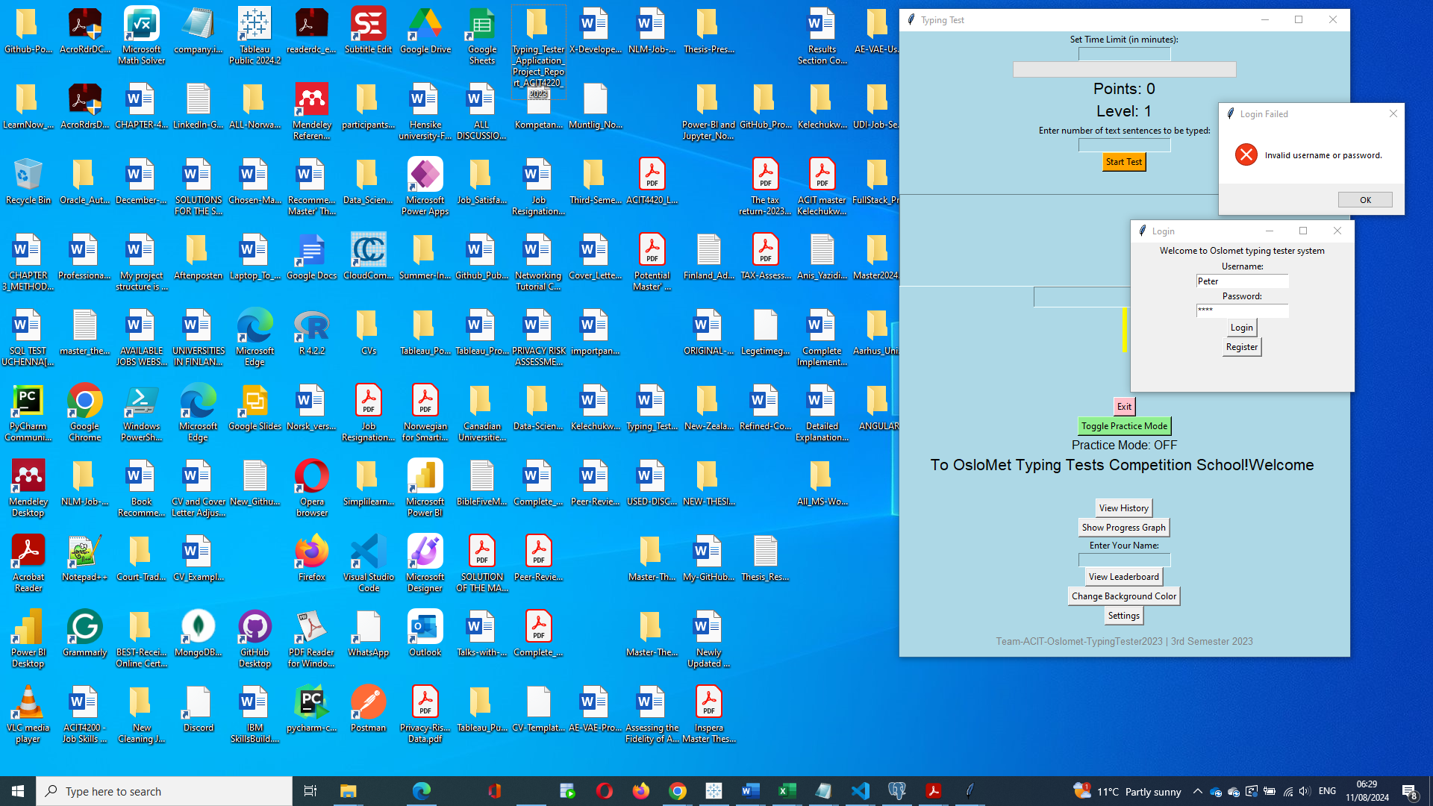

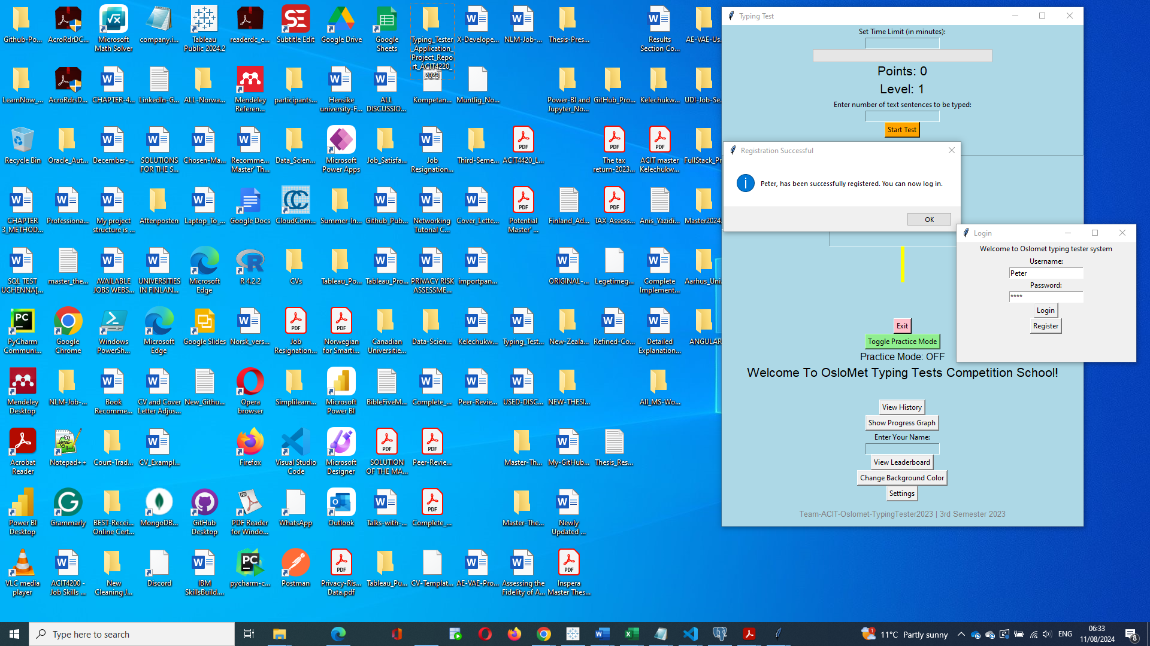

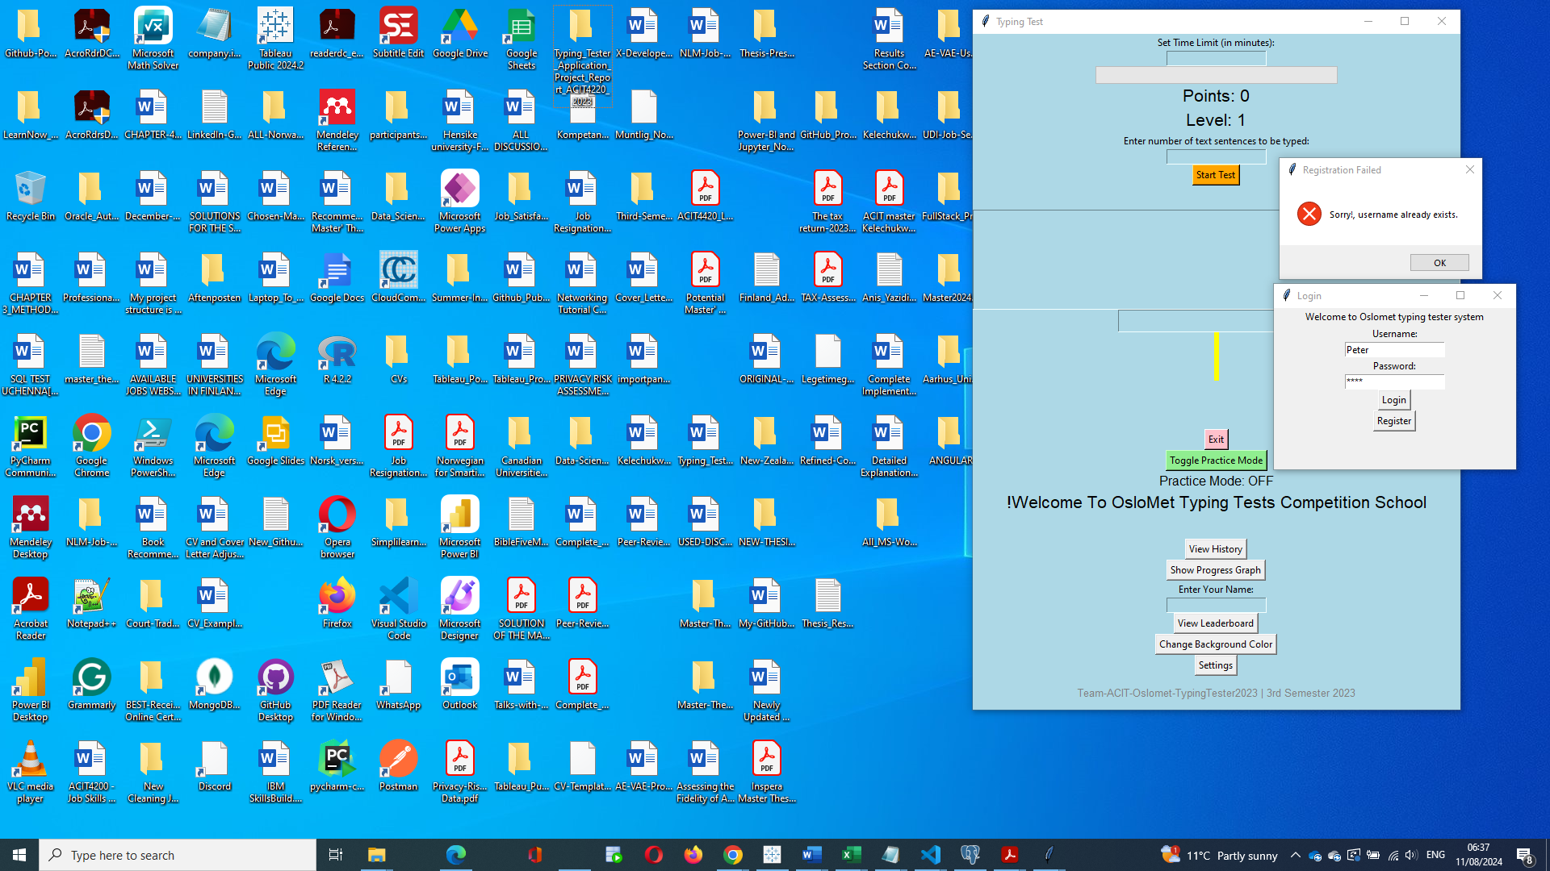

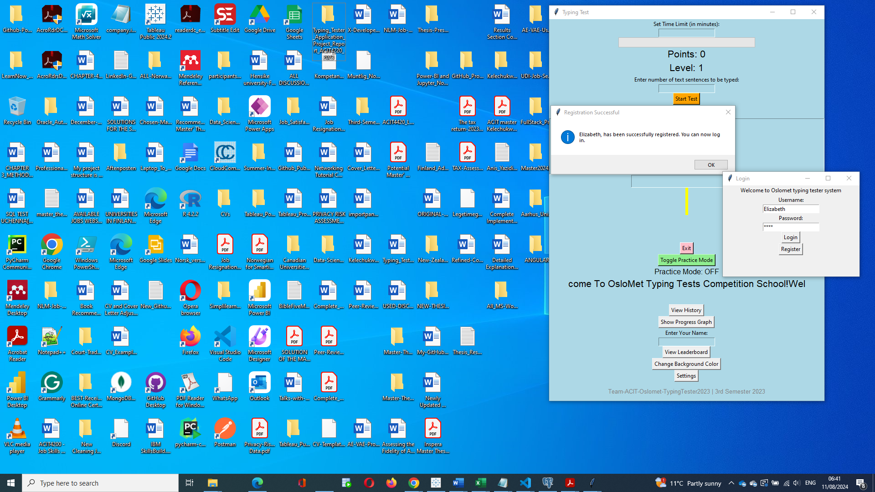

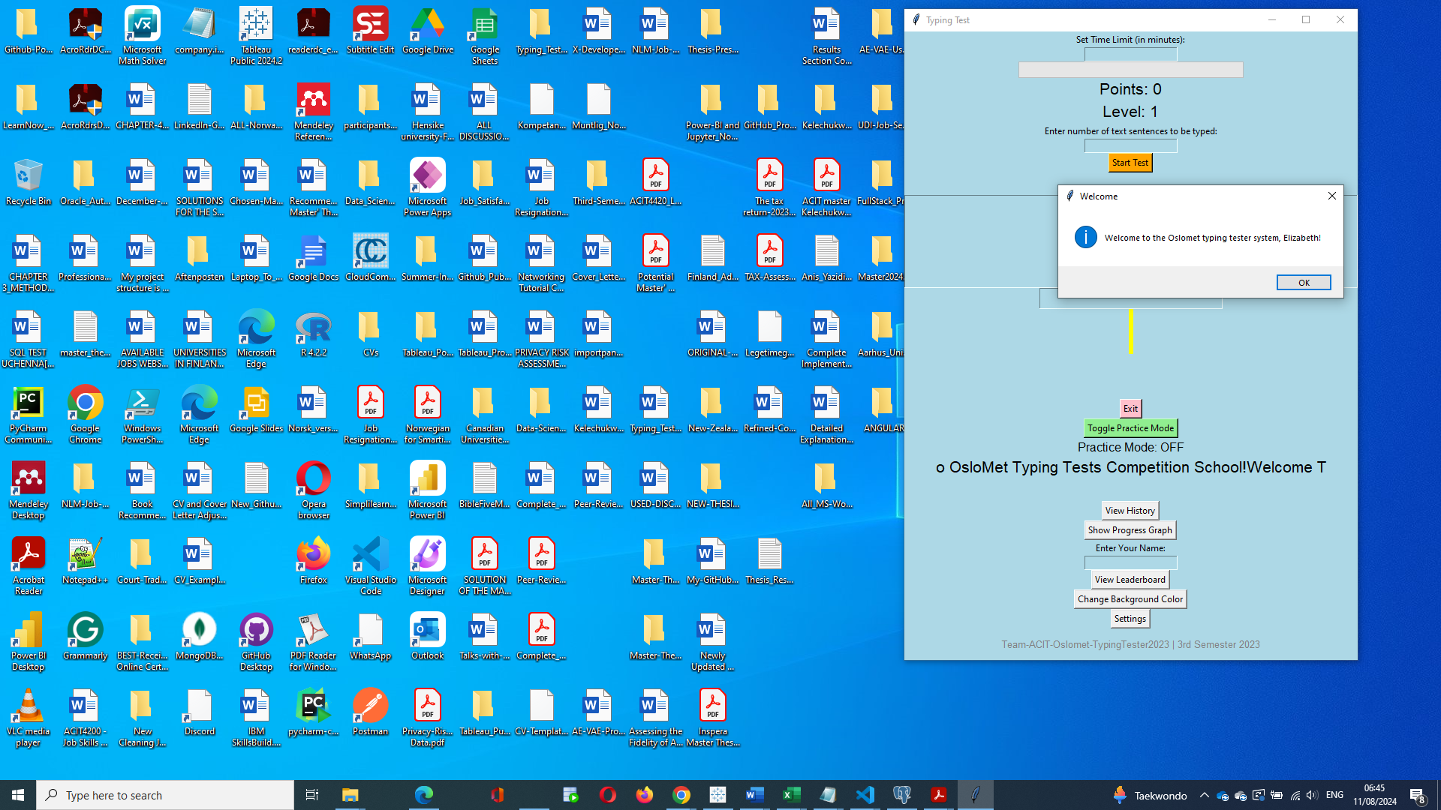

**First Typing Practise for Elizabeth**

Time Limit: 2minutes but converted into 120 seconds by the application

Number of Typed Sentences: 6

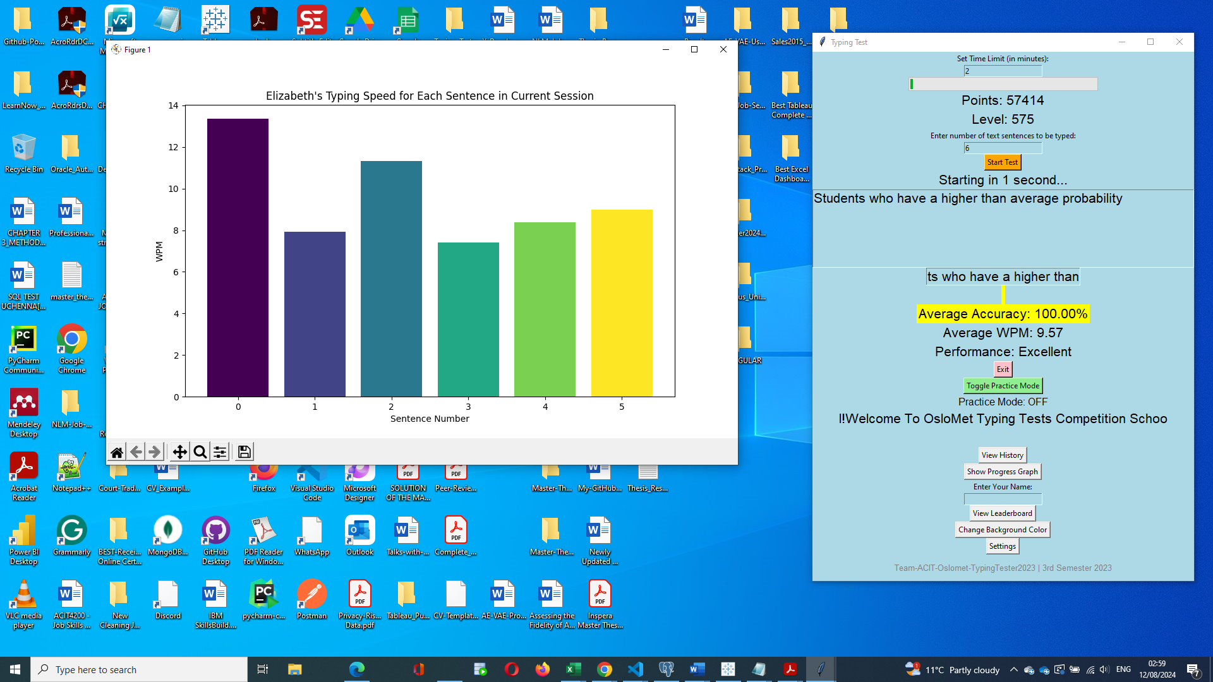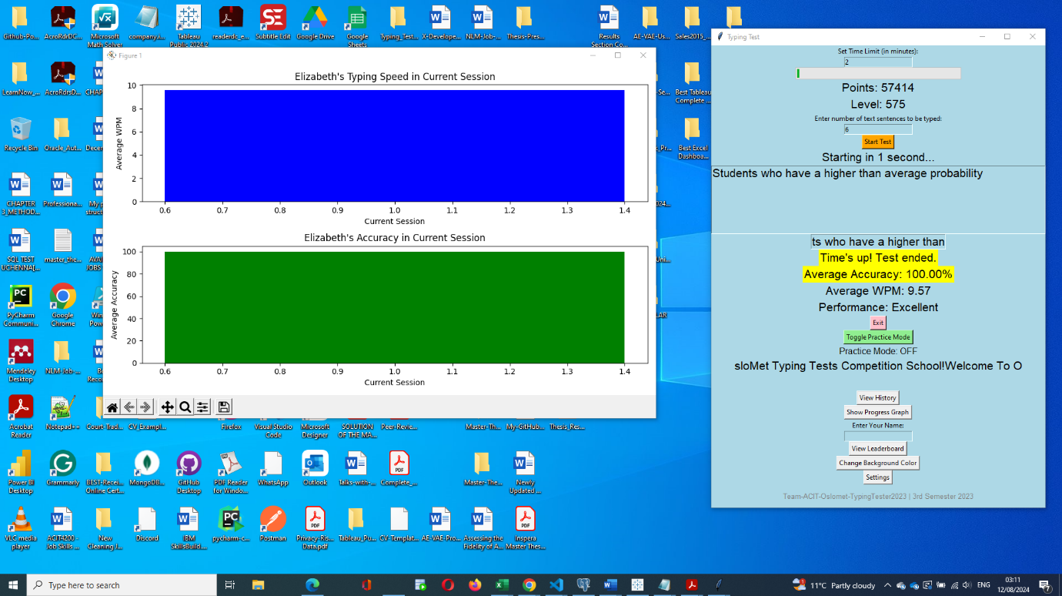

**Second Typing Practise for Elizabeth**

Time Limit: 2minutes but converted into 120 seconds by the application

Number of Typed Sentences: 4

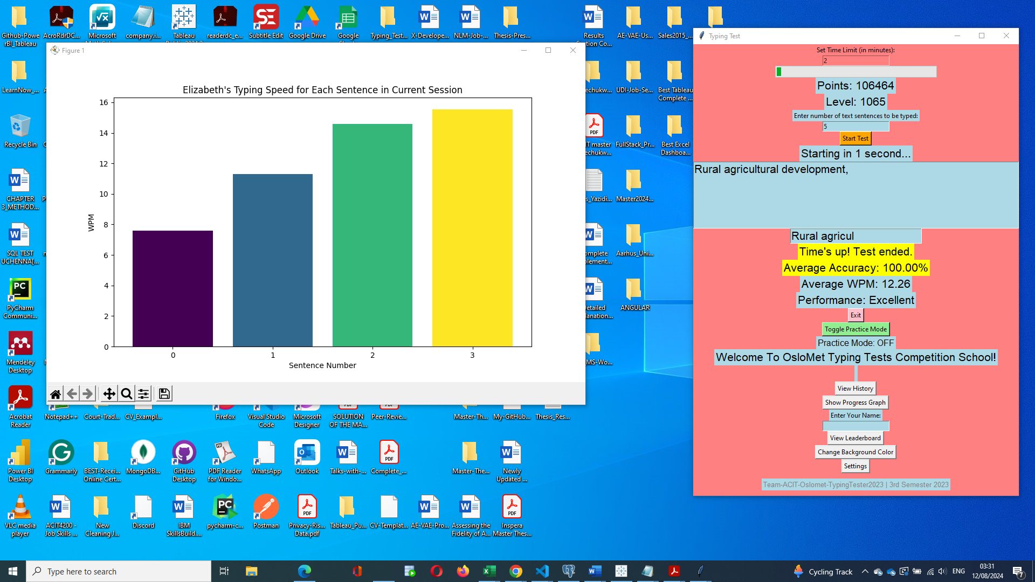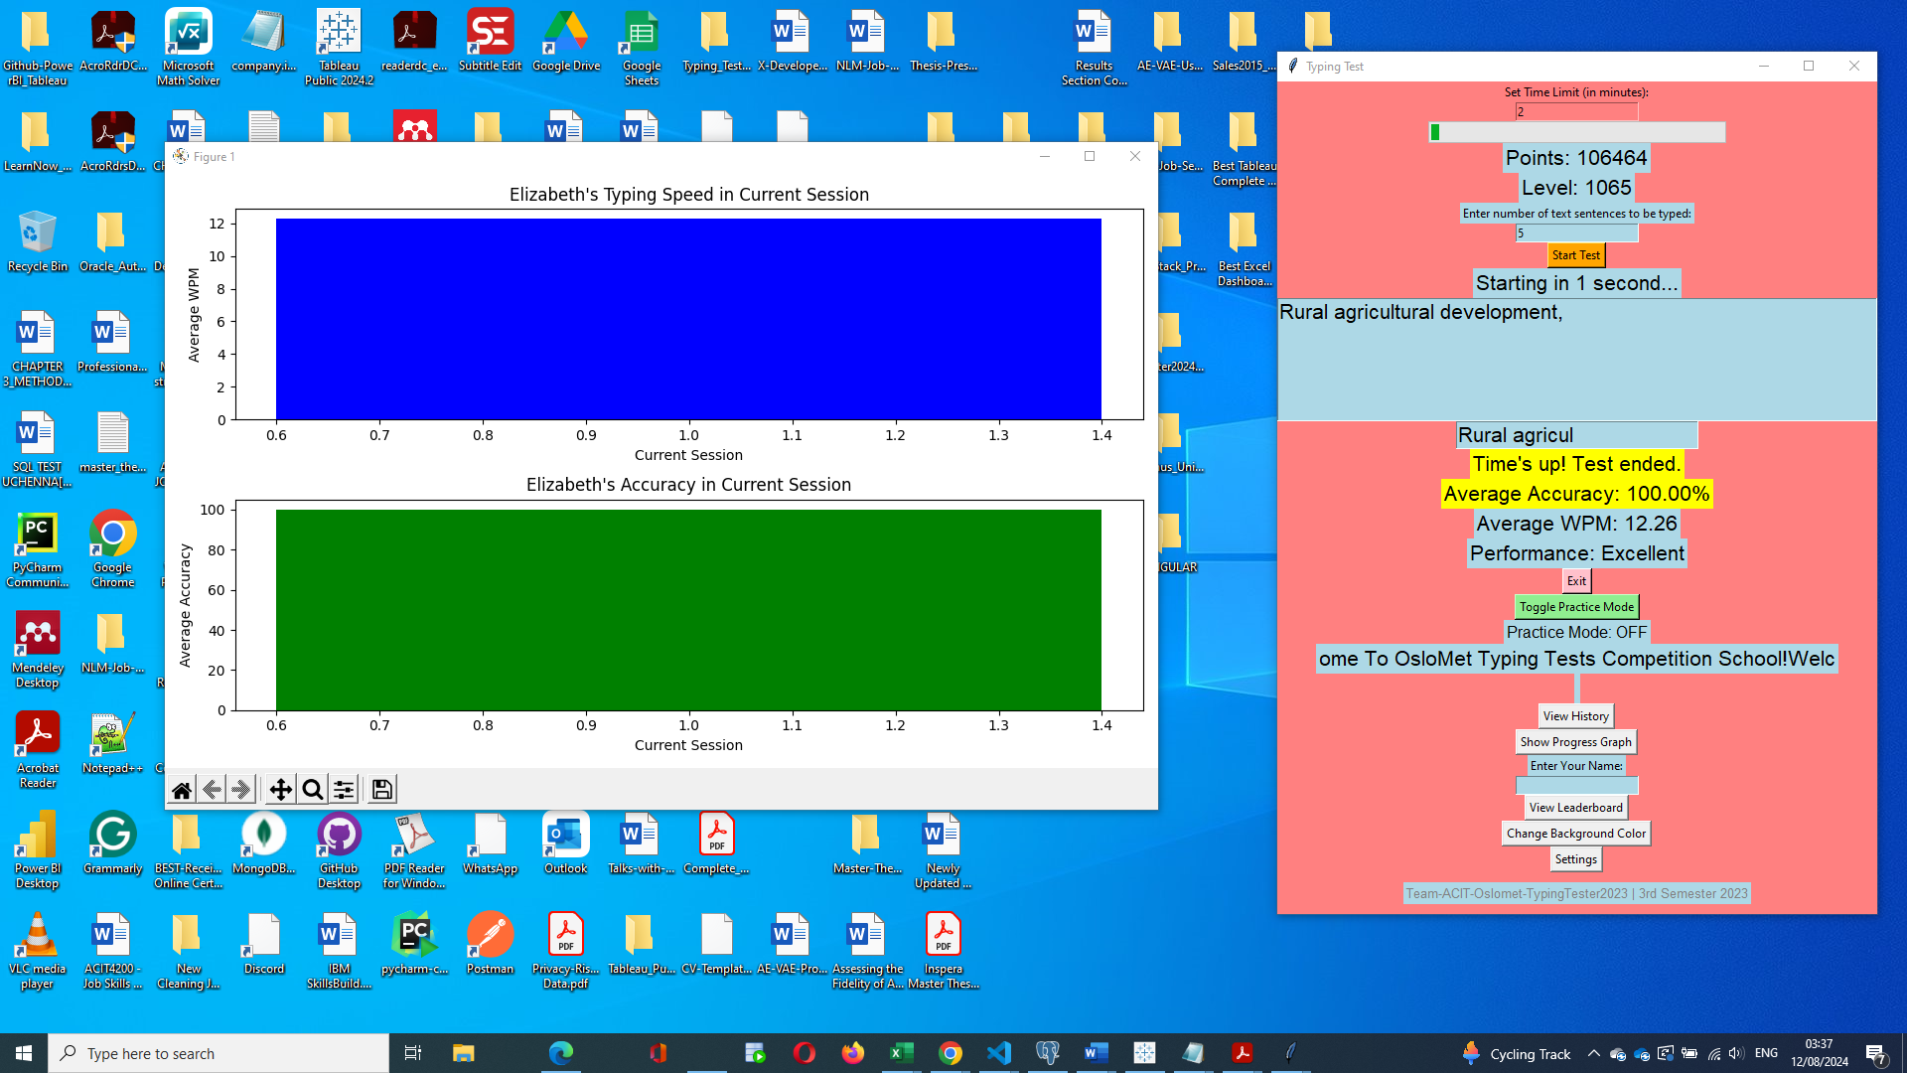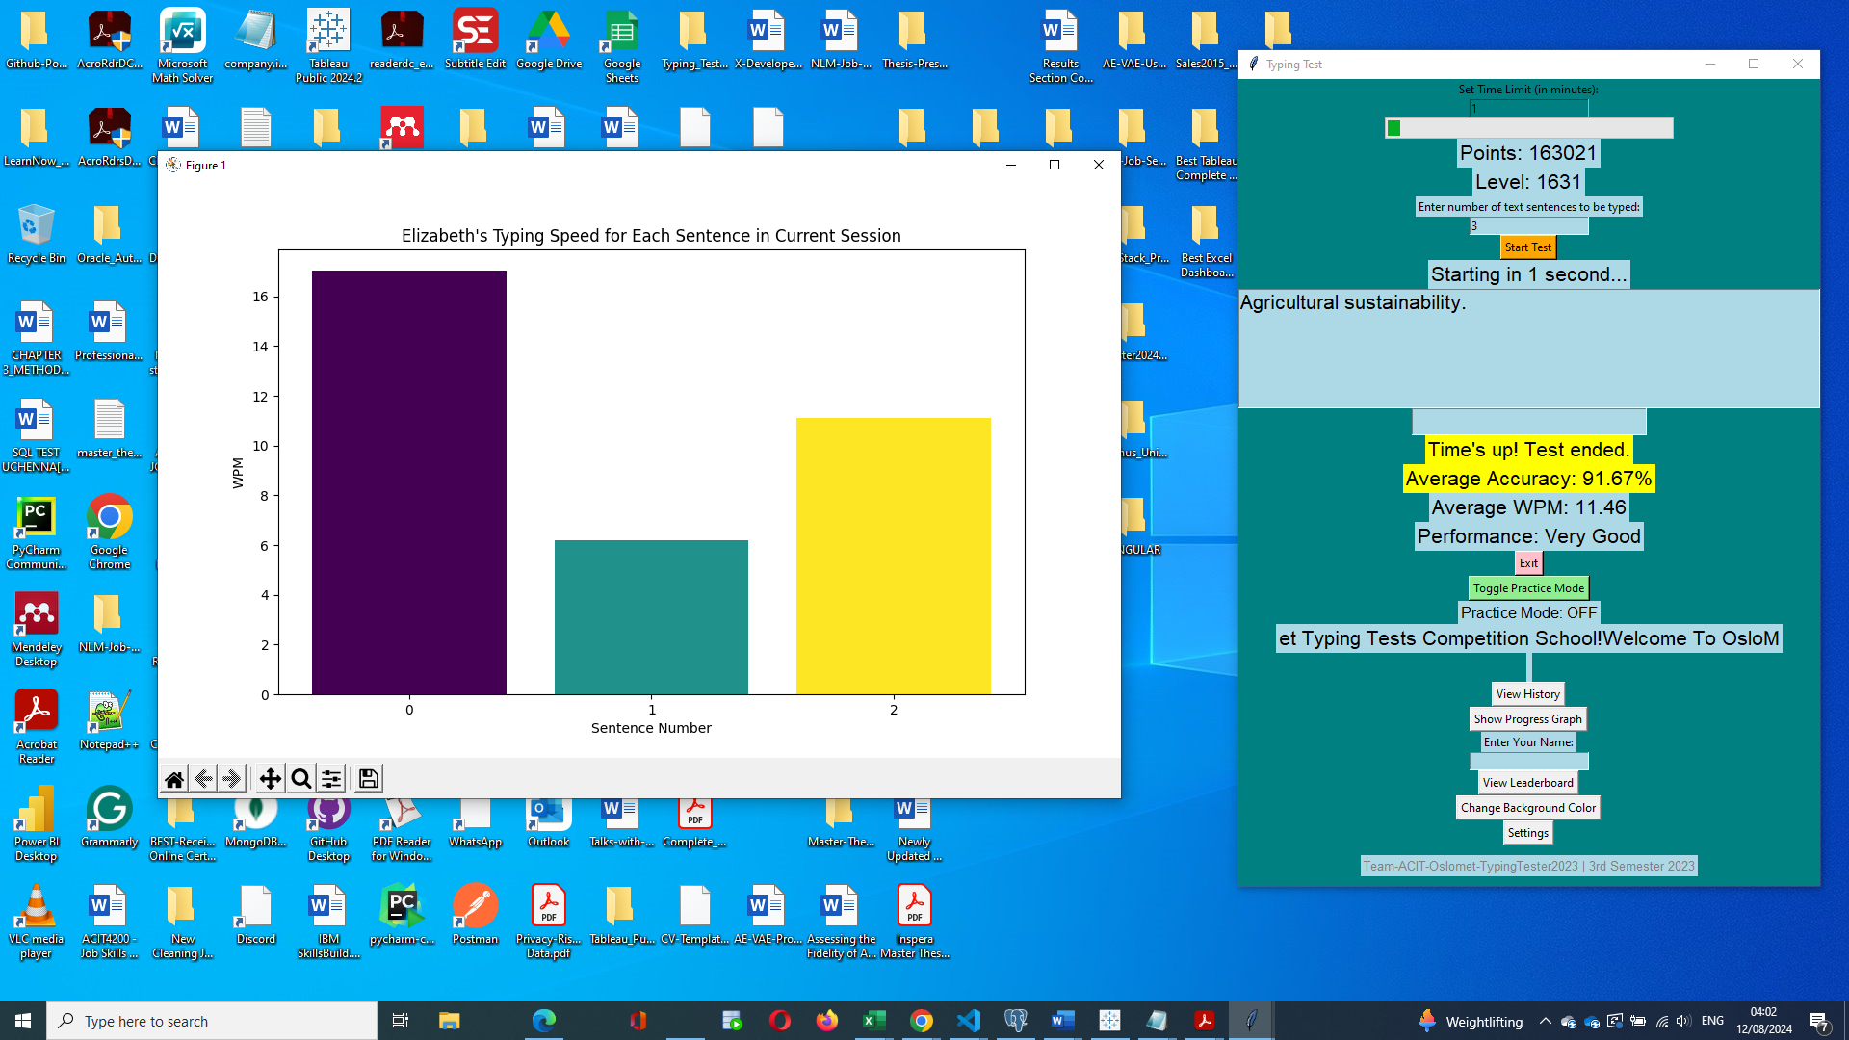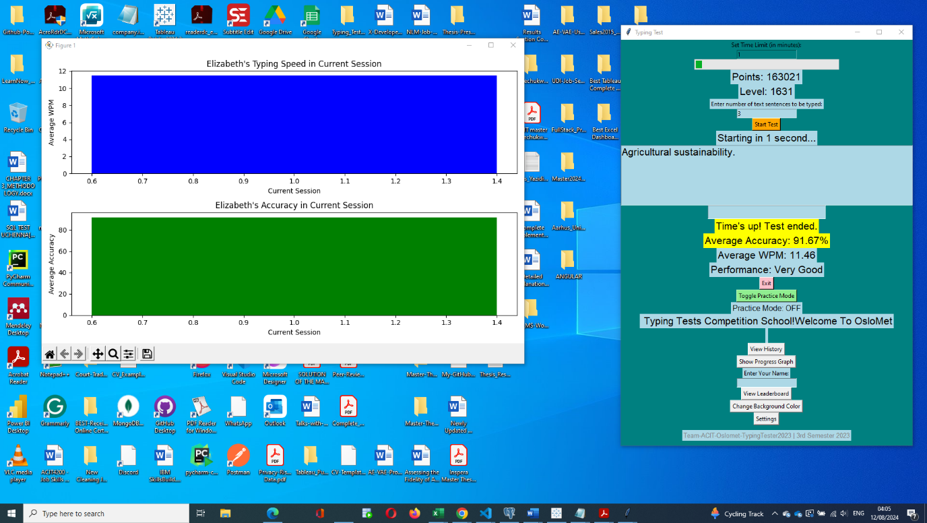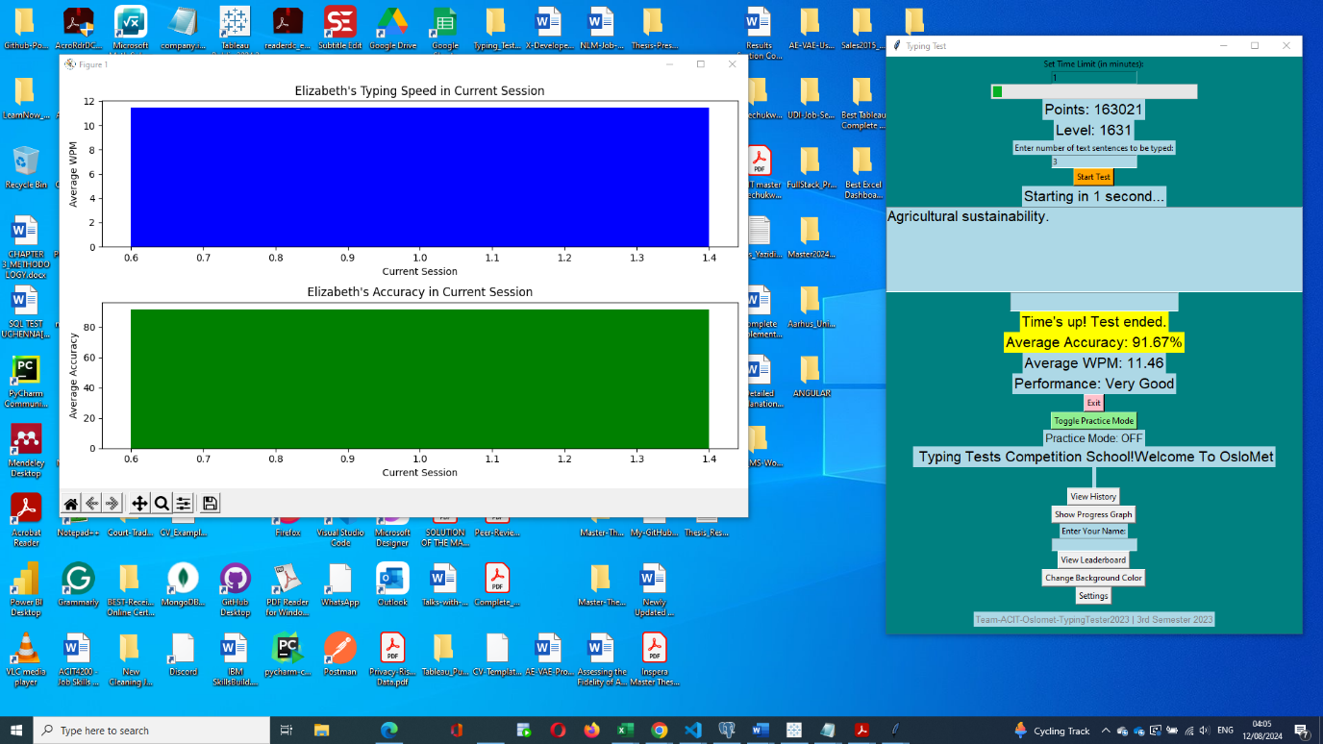

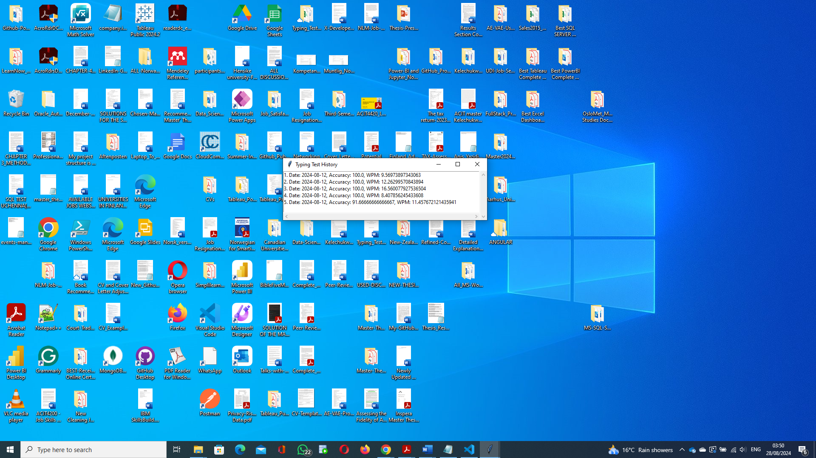

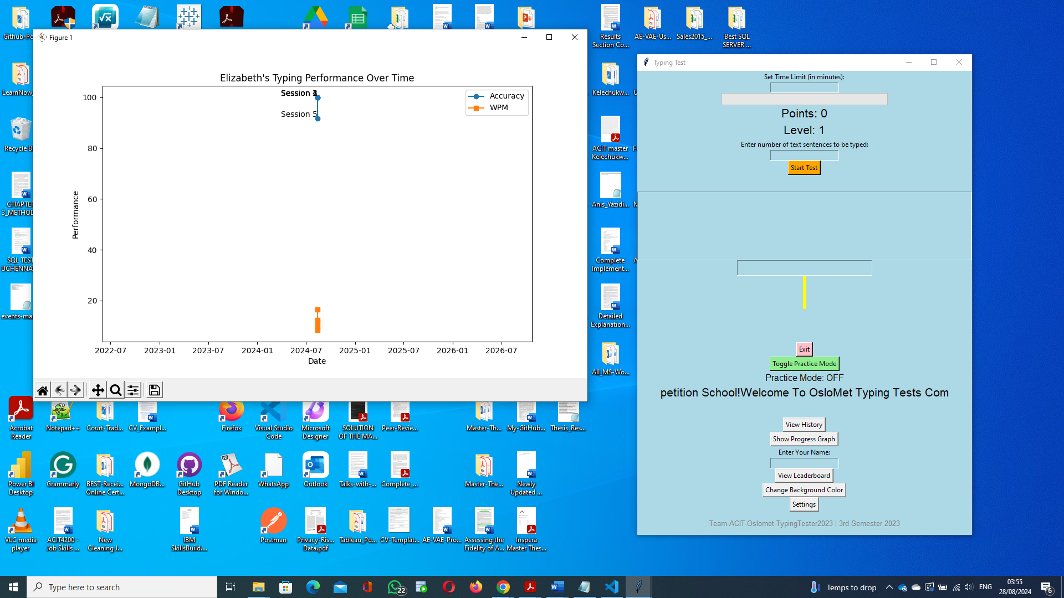

**First Typing Practise for Peter**

Time Limit: 2minutes but converted into 120 seconds by the application

Number of Typed Sentences: 5

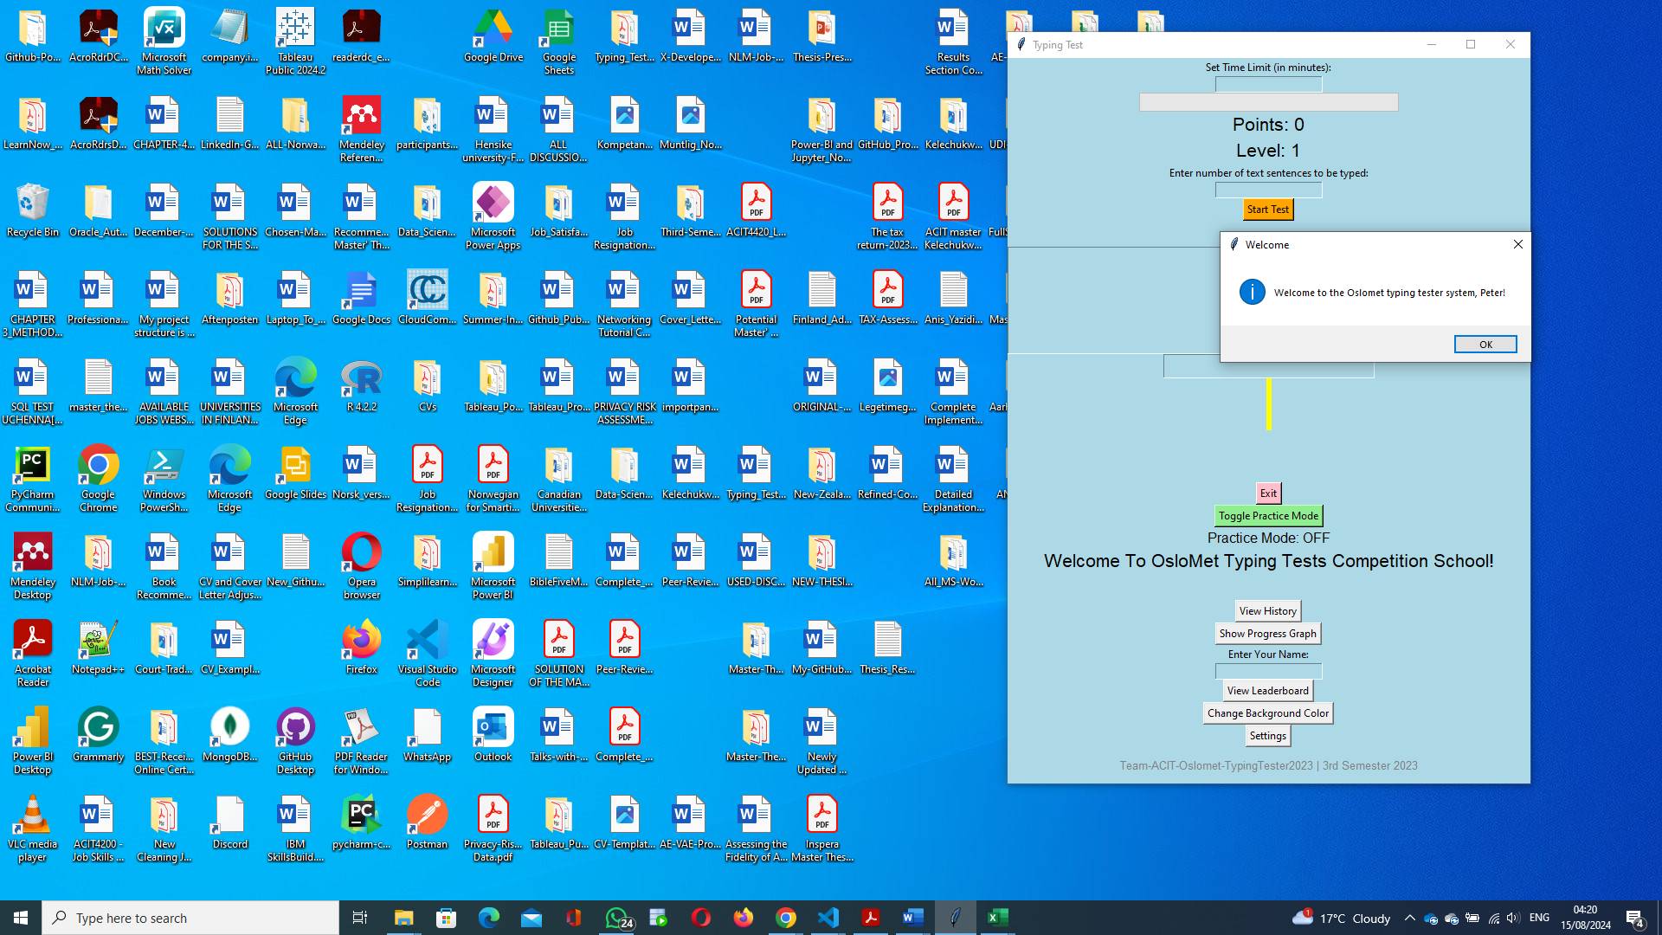

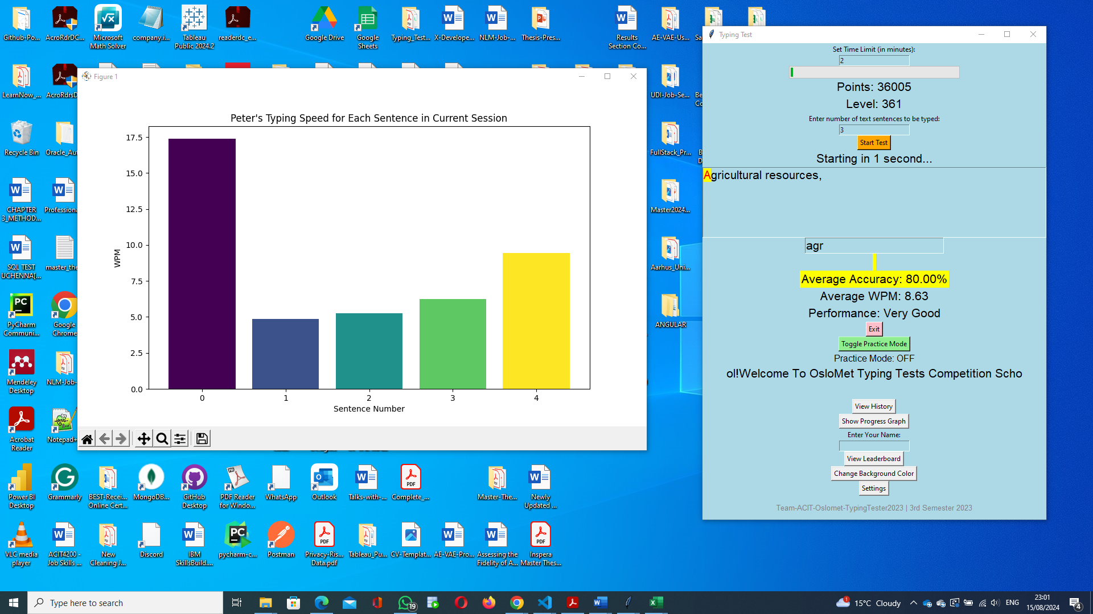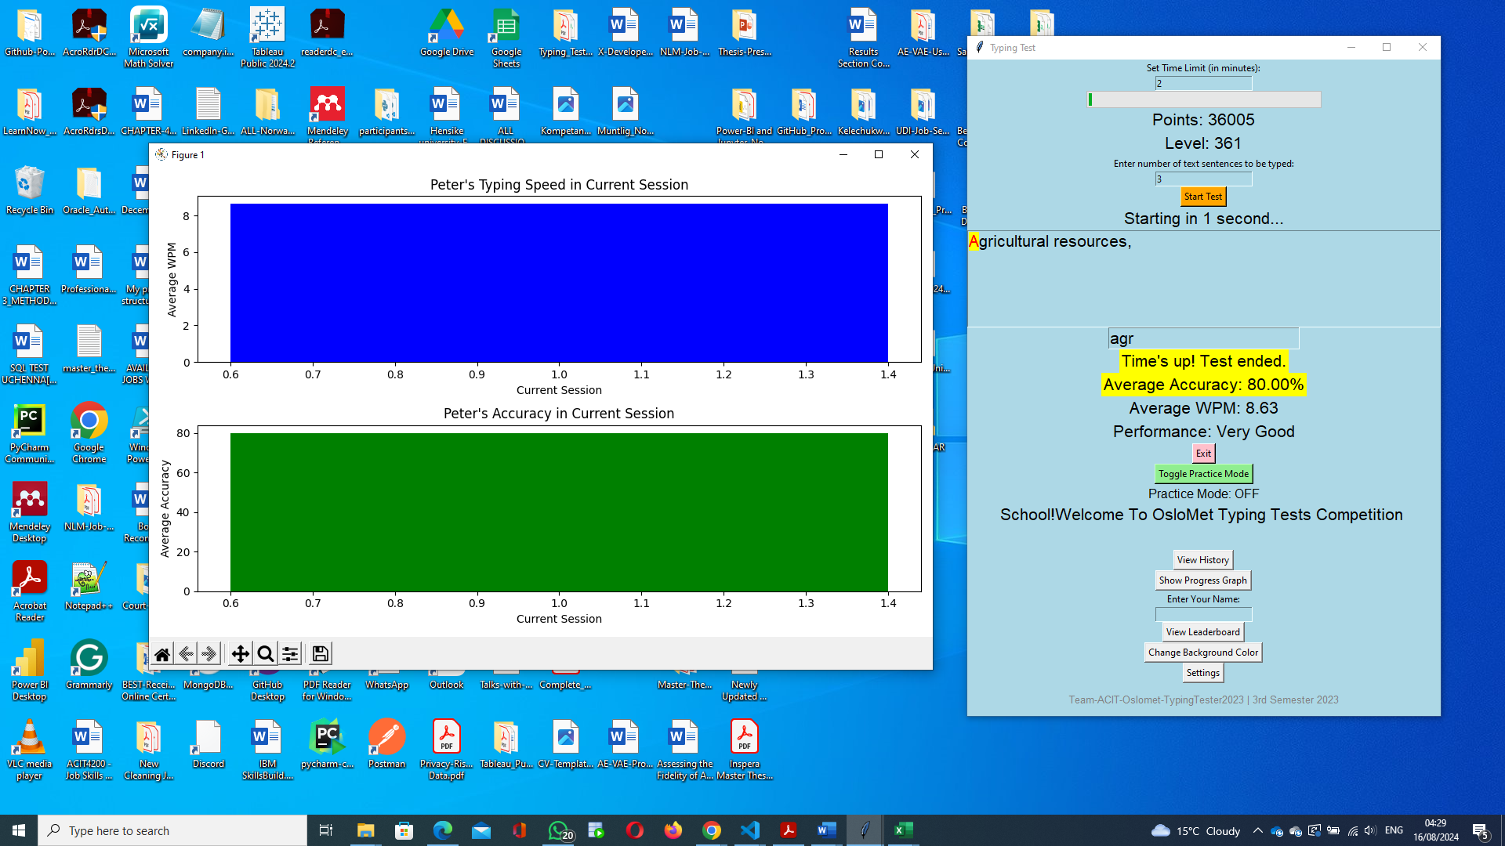

**Second Typing Practise for Peter**

Time Limit: 3minutes but converted into 180 seconds by the application

Number of Typed Sentences: 7

